INSIGHT STREAM

Project Documentation

1. Introduction

Project Title: Insight Stream

Team Members:

* M.Abdullah
* V.Prakash
* P.Sree varshan
* S.Mohammed umar

2. Project Overview

Purpose:

 To fetch and display the latest news articles from News API in a user-friendly interface, allowing users to browse top headlines, search news by keyword, and filter by categories.

Features:

 • Display top headlines

 • Search news by keyword

 • Category-based filtering (Technology, Business, Sports, etc.)

 • Responsive design

 • Links to full news articles

3. Architecture

Component Structure:

 • Single-page app structure with Header, SearchBar, NewsList, NewsCard components.

 • Components interact via props and state.

State Management:

 • Local state management using React’s useState.

 • No external state library used.

Routing:

 • Simple one-page application (no react-router used).

4. Setup Instructions

Prerequisites:

 • Node.js installed

 • NPM installed

Installation:

 1. Clone repository:

  https://github.com/jeevasaraa/Insight-stream.git

 2. Navigate to project folder:

  cd news-api-app

 3. Install dependencies:

  npm install

 4. Start development server:

  npm start

5. Folder Structure

Client:

 • /src/components – Header, SearchBar, NewsList, NewsCard

 • /src/App.js – Main entry point

 • /public/index.html – HTML template

Utilities:

 • API service function in /src/api/newsApi.js

6. Running the Application

npm start

Runs the app in development mode. Open http://localhost:3000 to view in browser.

7. Component Documentation

Header: Displays app title.

SearchBar: Allows user to type keywords and submit search.

NewsList: Displays list of NewsCard components.

NewsCard: Displays individual news article (image, title, description, link).

8. State Management

Global State: None (Local component state only).

Local State:

 • articles – Array of news articles fetched from API.

 • searchTerm – User input from search bar.

9. User Interface

Screenshot Preview:

https://drive.google.com/file/d/13AHNODcd-t63-N69q-GpVhYwWfPUwYsl/view?usp=drivesdk

Features:

 • Top headlines displayed as cards

 • Search functionality

 • Category filter buttons

10. Styling

CSS used for layout and responsiveness (no CSS frameworks).

Custom styling for cards and layout with Flexbox.

11. Testing

Testing Strategy:

 Manual testing of fetching articles, searching keywords, and category filtering.

Code Coverage:

 No automated tests implemented.

12. Screenshots or Demo

 https://drive.google.com/file/d/13AHNODcd-t63-N69q-GpVhYwWfPUwYsl/view?usp=drivesdk

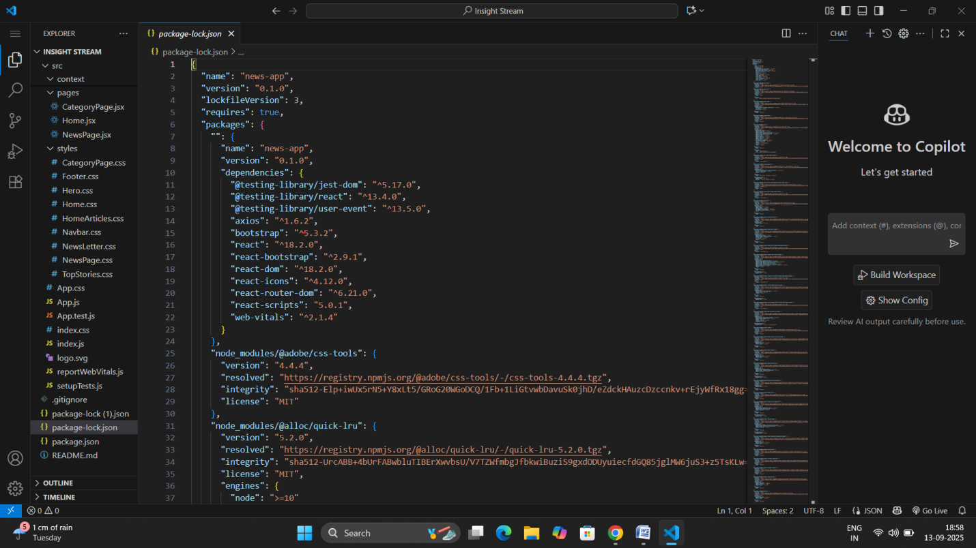

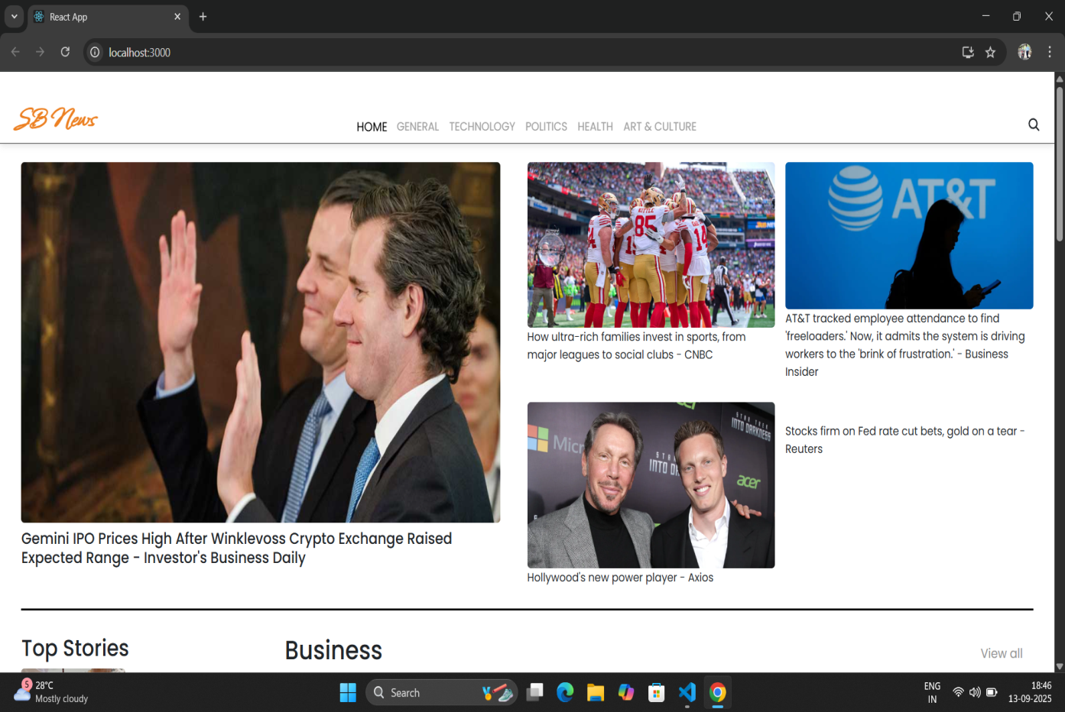

13. Known Issues

Occasionally, API limit exceeded (free tier restriction).

No pagination implemented (shows first 20 articles only).

14. Future Enhancements

Add pagination for articles.

Implement user favorites to save articles.

Add dark mode toggle.

Use Redux for scalable state management.